# --- GINA VALIDATOR MANUAL ---

Protocol to ensure proper GINA_Validator functionality:

1. Before recording any data from the GINA, install the following on your computer: [TDM Excel Add-In for Microsoft Excel Download](http://www.ni.com/example/27944/en/) . This will allow GINAs output TDMS files to be converted to xlsx files, which is required for this program to function.
2. Follow this checklist before commencing recording from the GINA and FlowLab:
   1. Both machines must calibrated to current atmospheric conditions (see GINA manual and FlowLab manual).
   2. Connect silicon pipes and connectors to approximate Figure 1. Connections must be as hermetic as possible.
   3. Both machines must for 10 minutes to warm up.
   4. Both machines must be set to have a sampling rate of 0.05s (200Hz).
      1. Set this on GINA through Log > Dec.Factor = 10 (Figure 3).
      2. Set this on FlowLab through Trending > Configuration > Recording interval = 0.05 (fig 4).
   5. In FlowLab, Trending > Configuration must set to record Time, Flow High, Flow Low, Pressure Difference and Tidal Volume Vte, (Figure 4).
   6. Ensure warning lights on GINA interface are not flashing (Figure 2).
   7. Under Log tab, change File Name to desired. Press ‘Store Set.’ and save this settings file with the same name as the File Name (Figure 3).
3. Commence recording. Interval between GINA and FlowLab start of recording must be less than 15 seconds.
4. After data recording is complete, open the GINA output tdms file using the *TDM Excel converter* and *save as*. Ensure that the GINA xlsx file and the FlowLab log file are both saved into the Tests_Data folder in the GINA Validator Files.
5. Open FileValidator application.
6. Use *Browse* buttons to select files.
7. *Name output file* in appropriate box. Name must contain no spaces and only the characters in these parentheses ( _ - . ).
8. Click *GO* to run validation. Plots will be displayed and stored in Tests_Results folder.

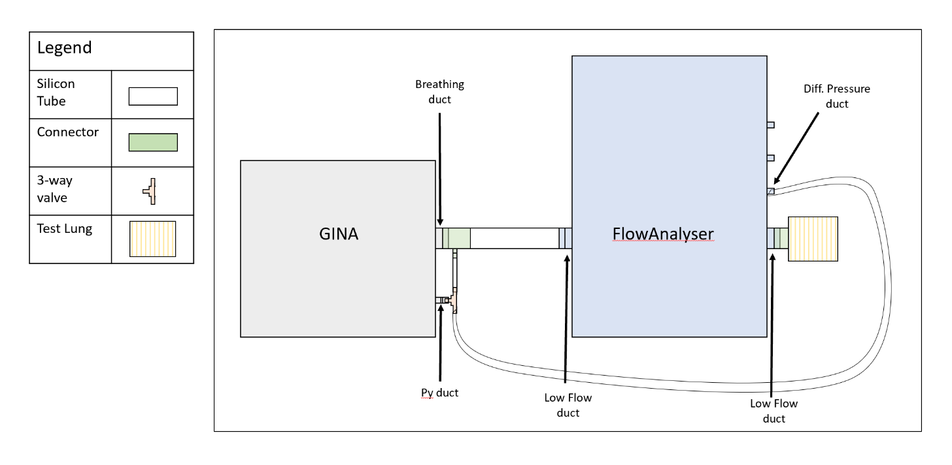

Figure : Set-up for GINA to FlowAnalyser connection

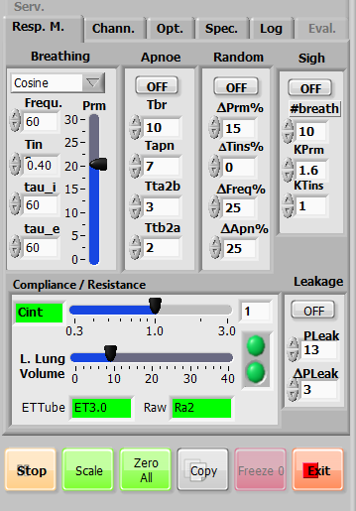

Figure : Respiratory Mechanics Setting, GINA v1-2. 'Lights' to the right of 'L.Lung Volume'

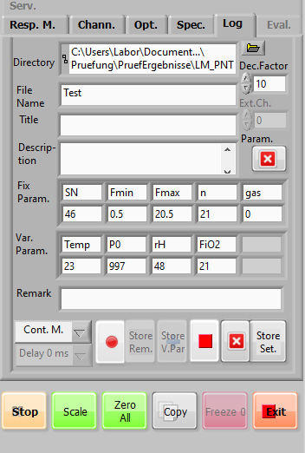

Figure : Log settings, GINA v1-2

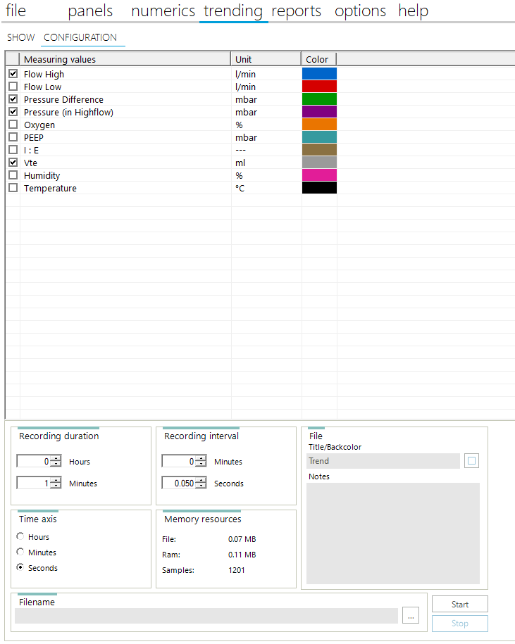

Figure : FlowLab settings

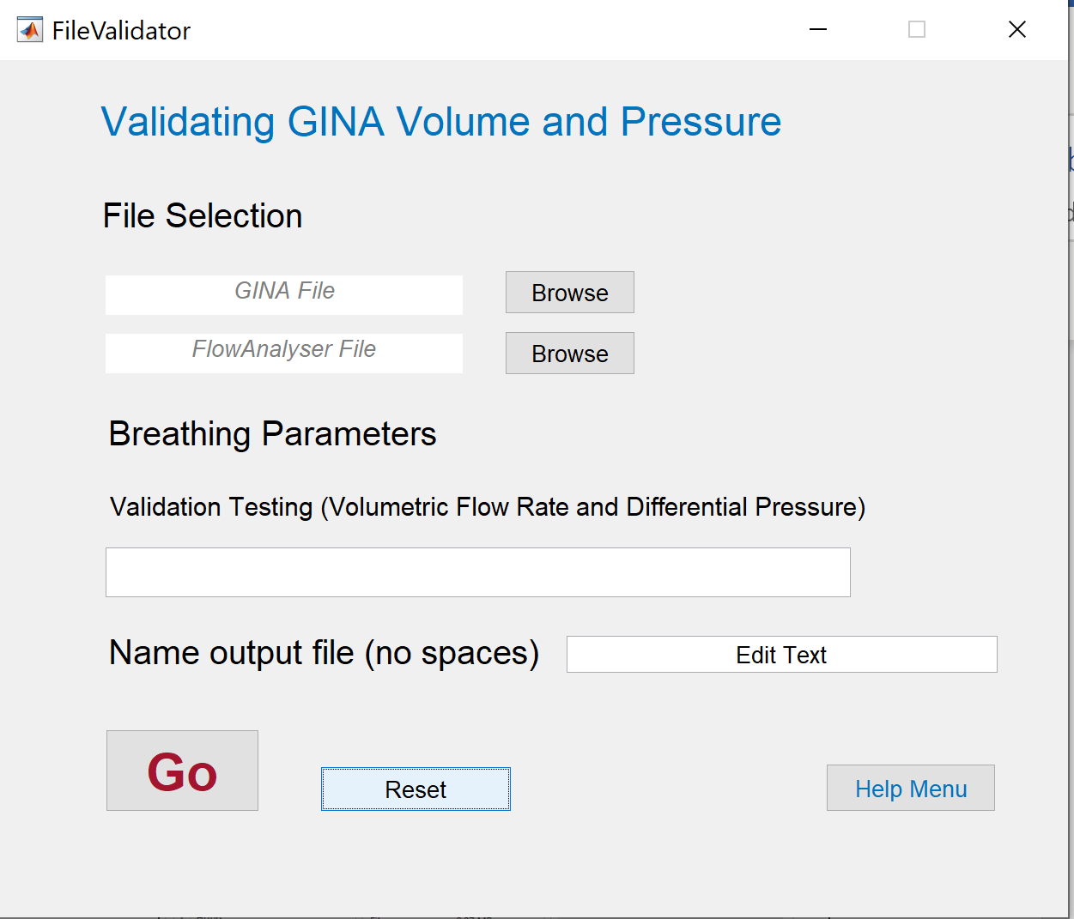

Figure : FileValidator GUI